Top k most frequent elements in the stream

Problem
Given an array a[] of size n and value k. Our task is to output elements in decreasing frequency till we reach (k+1)^{th} distinct element.

Example:
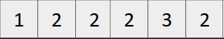
and k = 2

Output:
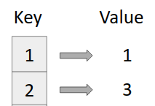

Approach
- Create a map (say freq)
map<int,int> freq;
- While traversing the array keep track of elements and when we find (k+1)^{th} distinct element, break from the loop.
- Output the element and frequency using map traversal.

Code
